Collin Real (yhi267)

DA 6823

Kilger

Module 3: Part #1 (20 points)

**Statistical Significance Versus Effect Size + Independent Samples t test**

**General Instructions:** In your own words, answer each of the following questions - don’t copy (e.g. cut and paste) some definition out of a book word for word. This is not a group project – you are expected to complete this module on your own. You may refer to text books, online or other sources but not your fellow classmates. If you don’t understand the question, feel free to ask the instructor in class, in office hours or in an email.

Here is the SAS printout for an independent samples ttest that compares advertising receptivity (scale =person has low ad receptivity, 5=person has high ad receptivity) between males (gender=1) and females (gender=0).

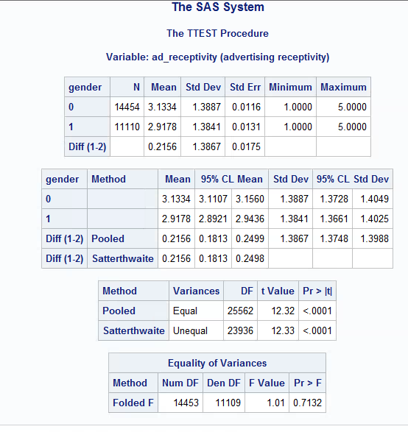

1. State the null and alternative hypotheses for the 2 independent sample t test. (4 points)

Equal Variance:

Null: Males and females have the same variance.

Alternative: Males and females have different variances.

2 Sample (Pooled) T Test:

Null: Ad receptivity means for males and females are equal.

Alternative: Ad receptivity means for males and females are not equal.

1. Name two assumptions of the 2 independent sample t test. ( 4 points)

Data in each group are normally distributed and variances for the two independent groups are equal.

1. What is the mean ad receptivity for males? For females? (2 points)

Males: 2.9178

Females: 3.1334

1. Does the data suggest that the variance of ad receptivity in males versus females is to be treated as equal or unequal? What is the p value for this test? ( 4 points )

Since the p-value (0.7132) is greater than the significance level (assuming 0.05), the data suggests equal variance since we do not reject the null hypothesis.

1. What can you conclude about the differences in ad receptivity between males and females? Given the differences in the data between males and females, explain why you were able to come to the conclusion that you did. (6 points)

We can conclude significant differences in ad receptivity between males and females. Since the p-value (0.0001) of the pooled t-test is less than the significance level (assuming 0.05), we reject the null hypothesis that the mean of male ad receptivity equals the mean of female ad receptivity.